Student: Mai Le

ID: i6375777

**Report of Assignment 2**

1. **Background**

Ventricular tachycardia (VT) is a potentially life-threatening arrhythmia leading to half of cardiac diseases-related deaths [1]. The most common cause of VT is ischemic heart disease, especially in patients experiencing prior infarction [1]. Catheter ablation has been demonstrated as an effective treatment for patients with VT who have arrhythmia refractory or resist anti-arrhythmia drugs [1, 2]. Despite reduced VT burdens, a recurrence rate over 40% after ablation remains a huge challenge in anti-arrhythmia treatment [3, 4]. To improve clinical outcomes, VT treatment strategies are shifting from one-size-fits-all towards one-size-fits-one. This personalized approach uses cardiac images of each patient to individuate arrhythmias’ substrate and trigger, select benefits people, or predict VT recurrence [5, 6].

Recent advances in precision VT treatment focus on integrating multi-modalities to provide individualized anatomical and functional information, thus facilitating accurate identification of vulnerable areas with arrhythmia for ablation [5]. In particular, computed tomography (CT), the most effective technique for detailed information on cardiac anatomy, can provide information about critical sites for VT ablation (*e.g.* scar region), wall thickness, hypoattenuation, and decreased perfusion [7-9]. However, CT requires exposure to high doses of radiation and iodinated contrast which may be risky in some patients, while cardiac magnetic resonance (CMR) imaging can obtain higher resolution without contrast [10, 11]. CMR integration mainly focuses on regions with a high risk of arrhythmias, such as increased transmural, scar border zones, and regions at the scar core–border zone [12, 13]. Advanced Late Gadolinium Enhancement (LGE)-CMR can accurately define epicardial and intramural scars to determine effective ablation option [14]. Although LGE-CMR is a gold standard for characterizing scars and mapping substrates, it still needs to be combined with other cardiac electrofunctional images to localize VT triggers. Electrocardiographic imaging (ECGI) integration can overcome this limitation as it reconstructs epicardial activation maps which enable the precise localization of reentrant VT circuits and exits [15, 16]. This approach also aids in characterizing dispersion of repolarization and mapping beat-to-beat dynamics which reflect the arrhythmogenesis mechanism and highly vulnerable areas [17, 18]. Therefore, multimodal image integrating CT, LGE-CMR, and ECGI offers a promising and noninvasive approach for personalized treatment of patients with scar-related VT.

1. **Aim**

This study aims to incorporate images from CT, LGE-CMR, and EGCI to pinpoint highly vulnerable areas to arrhythmogenesis in a 60-year patient as potential targets for personalized ablation to avoid VT recurrence.

1. **Methods**

CT image of left ventricle (LV) was utilized to assess wall thickness between epi-endocardial layers associated with scar formation and arrhythmogenesis substrate after infarction [9]. Areas with higher wall thickness (blue) were defined as healthy tissues whereas areas with lower wall thickness (red) were defined as wall-thinning tissues. Besides ParaView, LGE-CMR images were analyzed by MATLAB to precisely characterize dense scars, border zones, and healthy areas. First, pixel-signal intensity (PSI) values were normalized for maximal PSI. Two PSI-based cut-offs were applied to delineate the myocardial scar, in which normalized values >0.6 indicate dense scars, <0.4 indicate healthy areas, and 0.4–0.6 represent scar border zones [19]. CMR-based conductive channel images were then incorporated into each corresponding layer as corridors of the heterogeneous tissues penetrating scars and connecting to healthy zones [13]. The whole-heart epicardial activation maps reconstructed from ECGI were used to identify the earliest activation sites as VT exits. The position of VT exits was then overlaid with corridors from CMR-derived epicardium to investigate the VT trajectory and mechanism. 12-lead ECG was also utilized to characterize VT subtypes and origin based on QRS complex morphology.

1. **Results**

LV thickness analysis through CT shows wall thinning in the inferolateral and apical sides of LV (Figure 1), corresponding to this patient’s history of anterior/inferolateral myocardial infarction. LGE-CMR classified scar areas (red) and border zones (yellow) more accurately than CT. Although scar areas in the epicardial layer are smaller than in the endocardial layer, they are still located at the inferolateral and apical aspects of LV (Figure 2). Moreover, heterogeneous tissue corridors locate at the basal to mid-inferolateral and apical sides of LV epicardium, whereas appear at the basal inferolateral and apical aspects of LV endocardium (Figure 2). ECGI accurately localized the VT exit positions on the epicardium with the earliest activation time. Compared with CMR, these VT exits are adjacent to the epicardium’s heterogeneous tissue corridors, suggesting that these corridors could serve as arrhythmic pathways including slow-conducting channels (isthmuses) that VT needs to travel to reach the exit sites (Figure 3).

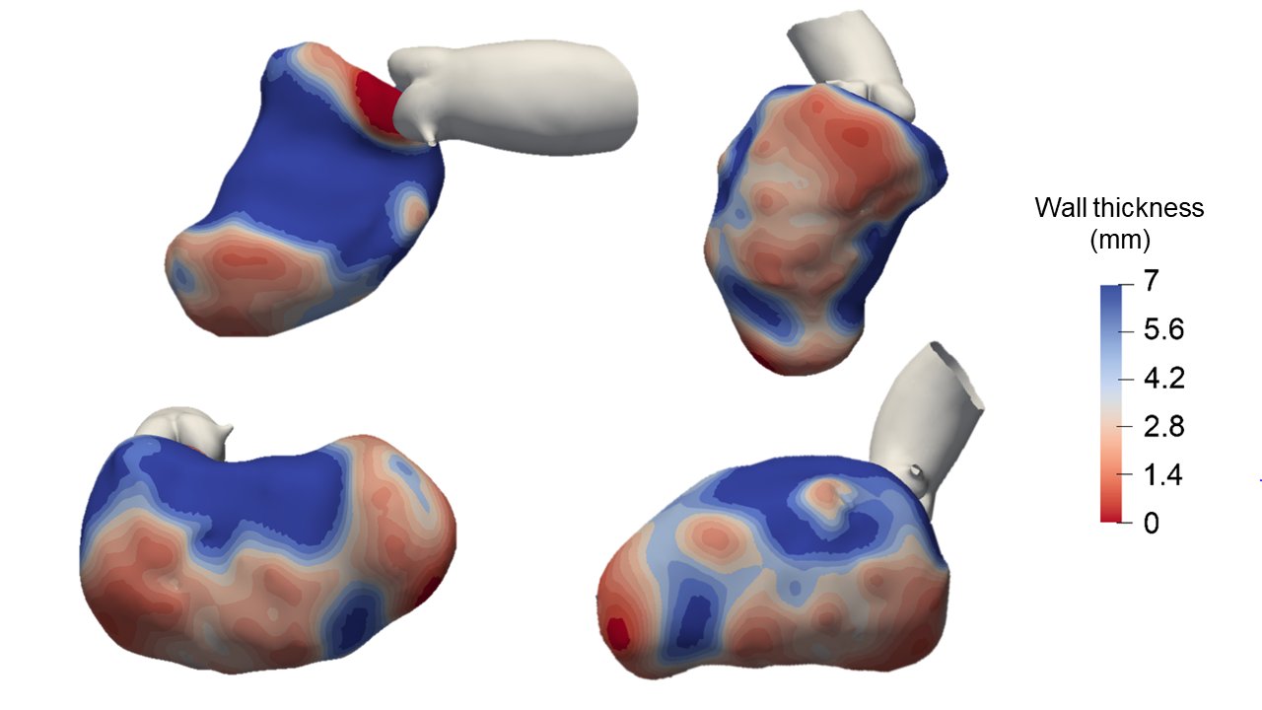

**Figure 1: CT images of LV wall thickness.**

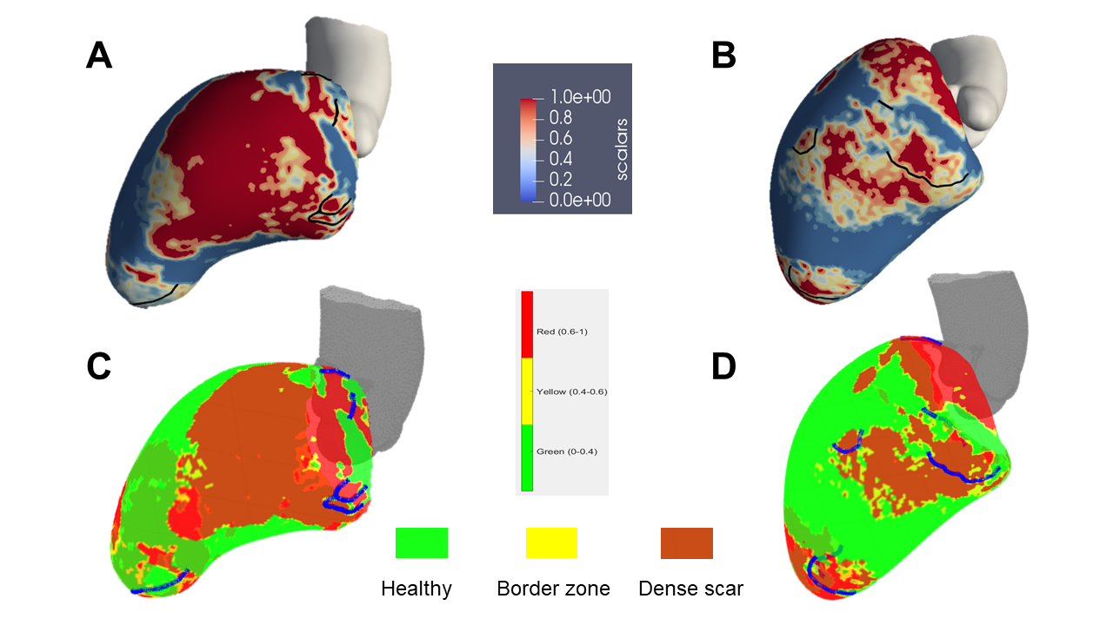

**Figure 2: LGE-CMR images of scar distribution on endocardial (A-C) and epicardial (B-D) layers. Black lines and blue lines both indicate corridors.**

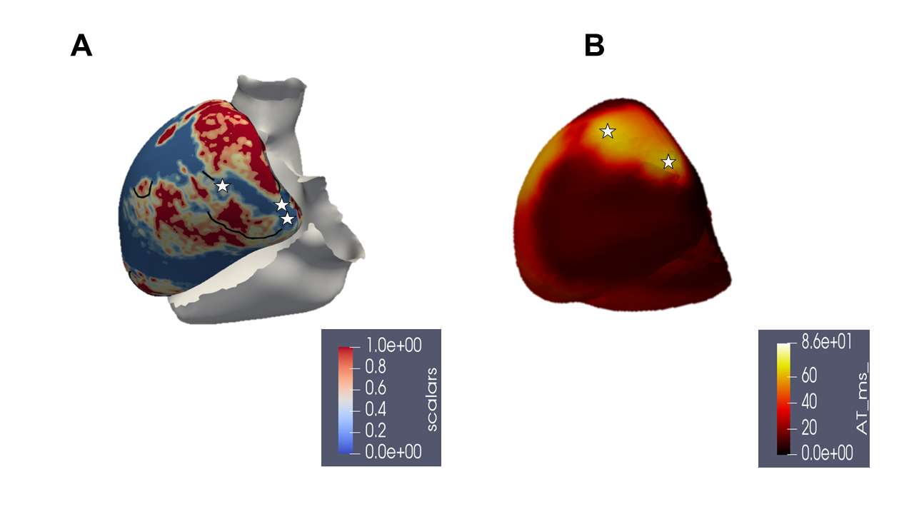

**Figure 3: The localization of VT exits (stars) on LV epicardial layer from LGE-CMR (A) and ECGI (B).**

1. **Discussion**

Pathological Q waves from ECG of sinus rhythm and monomorphic VT with an inferoseptal origin again demonstrated post-myocardial infarction which led to the scar-related VT in this patient (Figure 4). However, ECG becomes less accuracy when scars represent. Additionally, CMR successfully defined areas of scar heterogeneity initiating VT circuit and slow-conducting or blocked electricity as pathways for reentry. ECGI denoted the colocalization of VT exits near the end of heterogeneous tissue corridors, suggesting the VT mechanism and trajectory. These VT exits, entrances, and corridors connecting them should be ablated.

Although this approach can provide a roadmap to identify scar-related VT substrate and trigger, it needs an optimal step for scar quantification. Moreover, CMR lacked the consideration of transmural scar at other layers and epicardial-ECGI was not able to detect VT exits on endocardium which can acquire using electroanatomic mapping. Finally, despite ECGI’s promise, challenges of low resolution to distinguish between low-amplitude signals at isthmus and high-amplitude signals at far-field should be address before widely adopted in clinical practice.

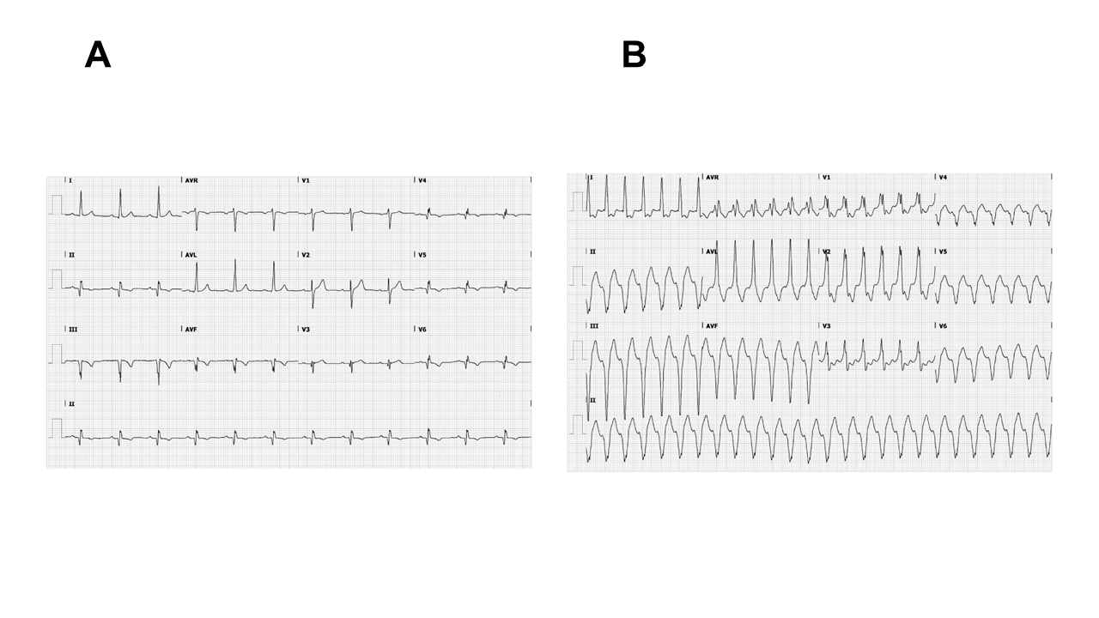

**Figure 4: Patient’s ECG during sinus rhythm (A) and VT (B).**

1. **Conclusion**

In conclusion, this approach combining structural CT and LGE-CMR with functional ECGI imaging could accurately pinpoint vulnerable areas with arrhythmia, including substrate and trigger, as precise targets for VT catheter ablation to improve clinical outcomes.

1. **References**

1. Foth, C., M.K. Gangwani, and H. Alvey, *Ventricular tachycardia.* 2018.

2. Nakahara, S., *Catheter ablation of ventricular tachycardia associated with structural heart disease: Current status and perspectives.* Journal of Cardiology, 2023. **81**(1): p. 57-62.

3. Quinto, L., et al., *Ventricular tachycardia burden reduction after substrate ablation: predictors of recurrence.* Heart Rhythm, 2021. **18**(6): p. 896-904.

4. Garcia Garcia, J., et al., *Impact of repeat ablation of ventricular tachycardia in patients with structural heart disease.* Europace, 2024. **26**(1): p. euad367.

5. Gimelli, A., S. Ernst, and R. Liga, *Multi-modality imaging for the identification of arrhythmogenic substrates prior to electrophysiology studies.* Frontiers in Cardiovascular Medicine, 2021. **8**: p. 640087.

6. Mahida, S., et al., *Cardiac imaging in patients with ventricular tachycardia.* Circulation, 2017. **136**(25): p. 2491-2507.

7. Hawson, J., et al., *Utility of cardiac imaging in patients with ventricular tachycardia.* Indian Pacing and Electrophysiology Journal, 2023. **23**(3): p. 63-76.

8. Tian, J., et al., *Three-dimensional contrast-enhanced multidetector CT for anatomic, dynamic, and perfusion characterization of abnormal myocardium to guide ventricular tachycardia ablations.* Circulation: Arrhythmia and Electrophysiology, 2010. **3**(5): p. 496-504.

9. Komatsu, Y., et al., *Regional myocardial wall thinning at multidetector computed tomography correlates to arrhythmogenic substrate in postinfarction ventricular tachycardia: assessment of structural and electrical substrate.* Circulation: Arrhythmia and Electrophysiology, 2013. **6**(2): p. 342-350.

10. Peebles, C., *Non-invasive coronary imaging: computed tomography or magnetic resonance imaging?* 2003, BMJ Publishing Group Ltd and British Cardiovascular Society. p. 591-594.

11. Nissen, S.E., *Limitations of computed tomography coronary angiography*. 2008, American College of Cardiology Foundation Washington, DC. p. 2145-2147.

12. Yokokawa, M., et al., *The characteristics and distribution of the scar tissue predict ventricular tachycardia in patients with advanced heart failure.* Pacing and clinical electrophysiology, 2009. **32**(3): p. 314-322.

13. Lin, L.-Y., et al., *Conductive channels identified with contrast-enhanced MR imaging predict ventricular tachycardia in systolic heart failure.* JACC: Cardiovascular Imaging, 2013. **6**(11): p. 1152-1159.

14. Bogun, F.M., et al., *Delayed-enhanced magnetic resonance imaging in nonischemic cardiomyopathy: utility for identifying the ventricular arrhythmia substrate.* Journal of the American College of Cardiology, 2009. **53**(13): p. 1138-1145.

15. Burnes, J.E., B. Taccardi, and Y. Rudy, *A noninvasive imaging modality for cardiac arrhythmias.* Circulation, 2000. **102**(17): p. 2152-2158.

16. Wang, Y., et al., *Noninvasive electroanatomic mapping of human ventricular arrhythmias with electrocardiographic imaging.* Science translational medicine, 2011. **3**(98): p. 98ra84-98ra84.

17. Vijayakumar, R., et al., *Methodology considerations in phase mapping of human cardiac arrhythmias.* Circulation: Arrhythmia and Electrophysiology, 2016. **9**(11): p. e004409.

18. Oster, H.S., et al., *Noninvasive electrocardiographic imaging: reconstruction of epicardial potentials, electrograms, and isochrones and localization of single and multiple electrocardiac events.* Circulation, 1997. **96**(3): p. 1012-1024.

19. Stoks, J., et al., *High-resolution structural-functional substrate-trigger characterization: future roadmap for catheter ablation of ventricular tachycardia.* Frontiers in Cardiovascular Medicine, 2023. **10**: p. 1112980.